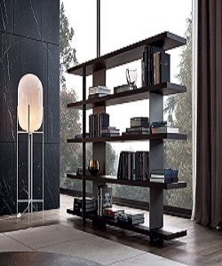

Poliform Bookcase

$91.50

Availability: In stock

**Description:**

Create classic-factor to your room with Poliform Bookcase. Shallow shelves help you to use small wall spaces effectively by accommodating small items in a minimum of space. Poliform Furniture’s are unique pieces for your home. This range includes Classic Dressers, Bookcases, TV Units, Desks, Writing Bureaus, Dining Settings, Occasional Chairs, Chesterfield Sofas and a Bedroom Collection that will look stunning in your newly built or renovated home. Poliforms bringing the best of French Provincial Furniture to Australia at the best prices!